**Backing up an existing Azure Web App**

The Backup and Restore feature in [Azure App Service](https://docs.microsoft.com/en-us/azure/app-service/overview) allows us to easily create app backups manually or on a schedule. You can configure the backups according to your comfort. You can restore the app to a snapshot of a previous state by overwriting the existing app or restoring to another app.



**PREREQUISITES**:

* You need to have an active Azure Subscription. If you not have you can sign-up for a free [**Account**](https://azure.microsoft.com/en-in/free/) **.**
* An existing Web App hosted in Azure. For creating a Web App you can follow this [**blog**](https://www.c-sharpcorner.com/blogs/creating-an-azure-web-app-and-enabling-security-authentication2) .

**Note**: App Service can back up the following information to an Azure storage account and container that you have configured your app to use.

* App configuration
* File content
* Database connected to your app

**Task 1st** : Configure Storage Account.

* In the [Azure portal](https://portal.azure.com/), navigate to your app's page, select **Backups**.

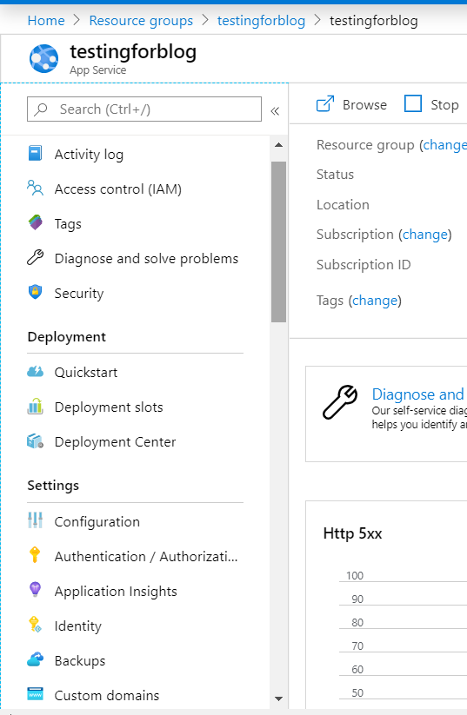

* The Backups Page is displayed.

**Note**: If you see the following message, click it to upgrade your App Service plan before you can proceed with backups. See this: [Scale up an app in Azure](https://docs.microsoft.com/en-us/azure/app-service/manage-scale-up).

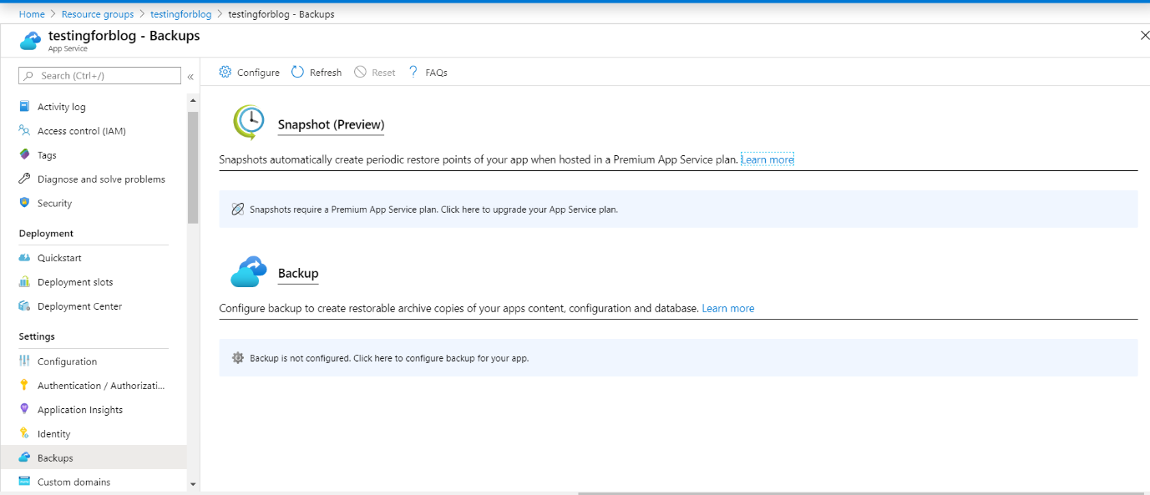

* In the **Backup** page, select **“Backup is not configured. Click here to configure backup for your app”**.

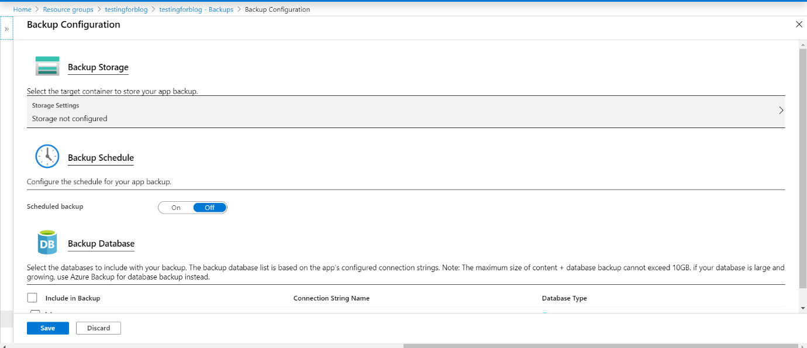

* In the **Backup Configuration** page, choose **“Storage not configured”** to configure a storage account.

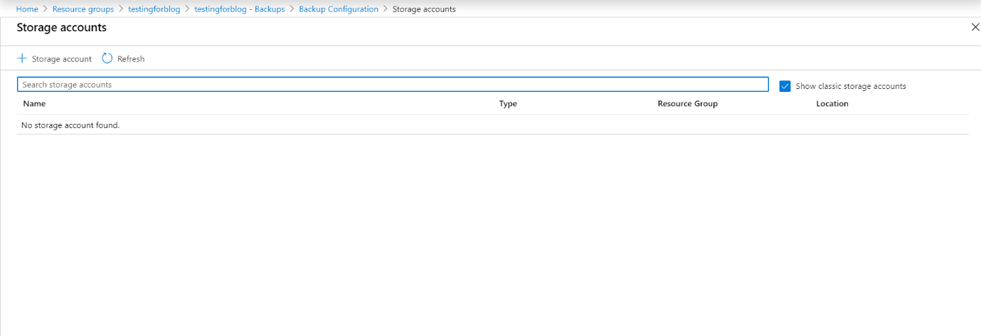

* Now you need to create a storage Account and container for your backup.

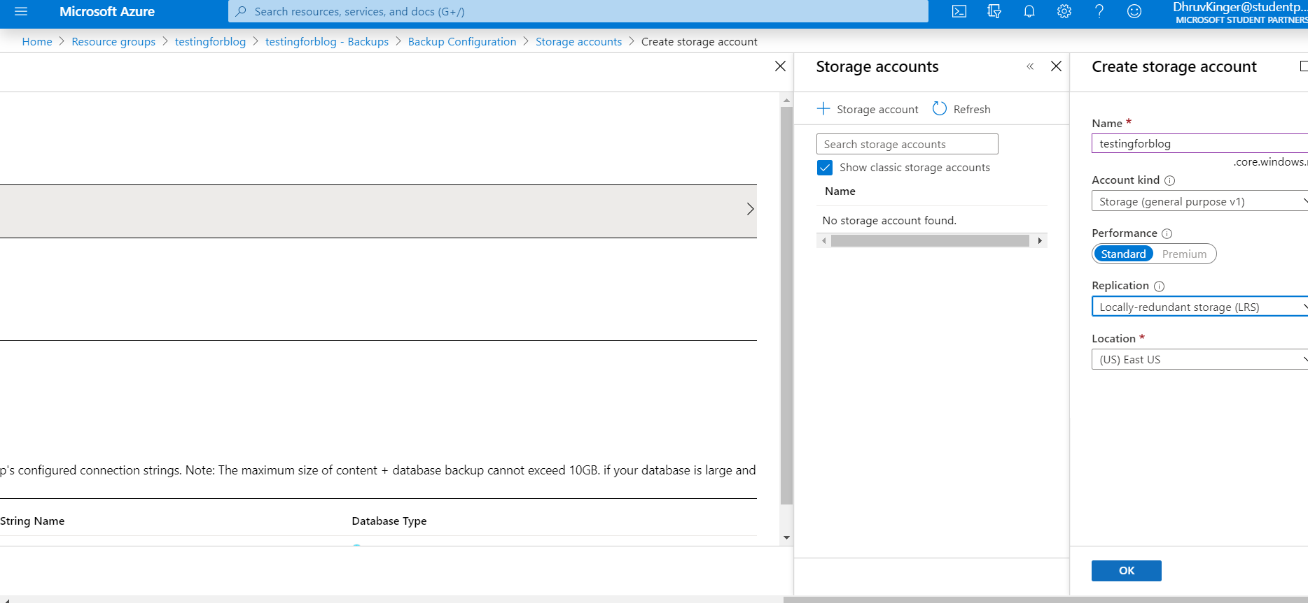

* After deployment of storage account here you will find like this :

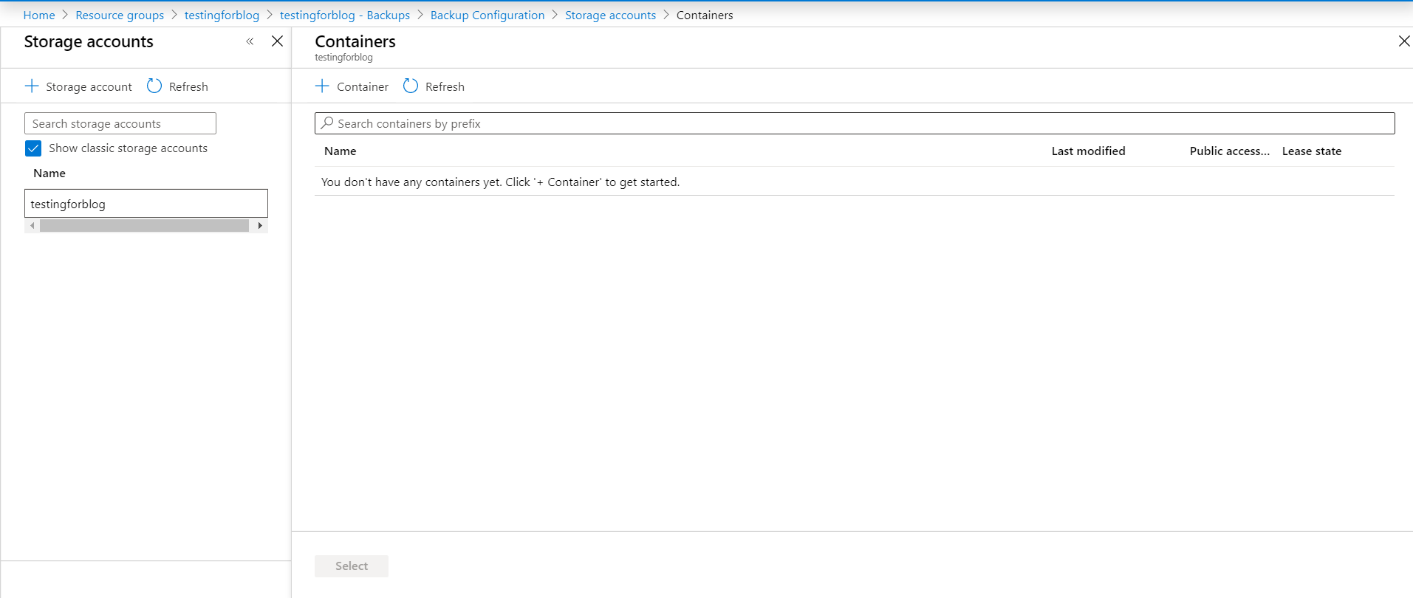

* So now we will create a container.

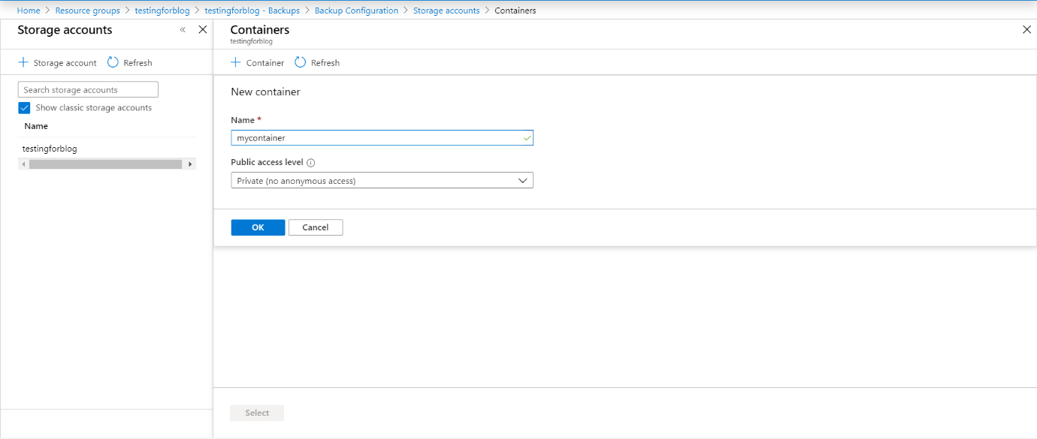

**Note**: So Our first task is completed. Now move to next task.

**Task 2nd** : Configure Backup Schedule & Database.

* In the **Backup Configuration** page, set **Scheduled backup** to **On**.

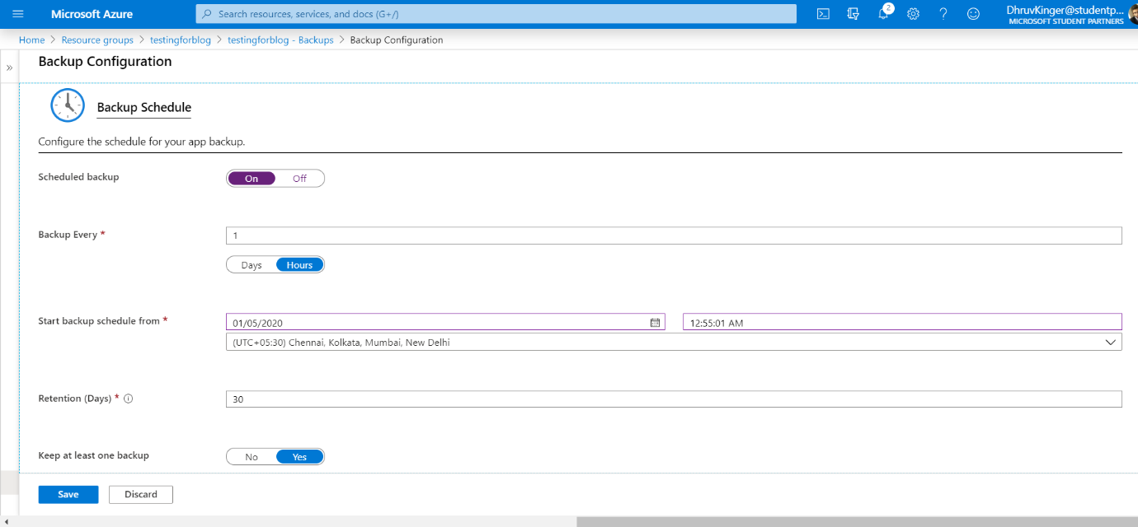

* Configure the backup schedule as desired and select **OK**.
* Now in **Backup Configuration Page**, we have to configure **Backup Database**. We have to include it in our Backup.

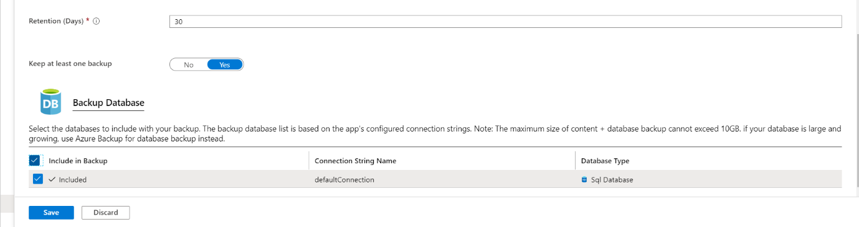

* So, finally our both tasks are completed.